Lab 1.4.1: Challenge Review

Topology Diagram
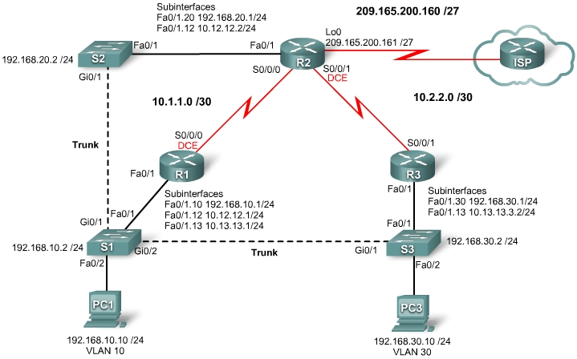

Addressing Table
Device | Interface | IP Address | Subnet Mask | Default Gateway
R1 | Fa0/1 | N/A | N/A | N/A
R1 | Fa0/1.10 | 192.168.10.1 | 255.255.255.0 | N/A
R1 | Fa0/1.12 | 10.12.12.1 | 255.255.255.0 | N/A
R1 | Fa0/1.13 | 10.13.13.1 | 255.255.255.0 | N/A
R1 | S0/0/0 | 10.1.1.1 | 255.255.255.252 | N/A
R2 | Fa0/1 | N/A | N/A | N/A
R2 | Fa0/1.12 | 10.12.12.2 | 255.255.255.0 | N/A
R2 | Fa0/1.20 | 192.168.20.1 | 255.255.255.0 | N/A
R2 | S0/0/0 | 10.1.1.2 | 255.255.255.252 | N/A
R2 | S0/0/1 | 10.2.2.1 | 255.255.255.252 | N/A
R3 | Fa0/1 | N/A | N/A | N/A
R3 | Fa0/1.13 | 10.13.13.3 | 255.255.255.0 | N/A
R3 | Fa0/1.30 | 192.168.30.1 | 255.255.255.0 | N/A
R3 | S0/0/1 | 10.2.2.2 | 255.255.255.252 | N/A
S1 | VLAN10 | 192.168.10.2 | 255.255.255.0 | 192.168.10.1
S2 | VLAN20 | 192.168.20.2 | 255.255.255.0 | 192.168.20.1
S3 | VLAN30 | 192.168.30.2 | 255.255.255.0 | 192.168.30.1
PC1 | NIC | 192.168.10.10 | 255.255.255.0 | 192.168.10.1
PC3 | NIC | 192.168.30.10 | 255.255.255.0 | 192.168.30.1

Learning Objectives
To complete this lab:
- Cable a network according to the topology diagram.
- Erase the startup configuration and reload a router to the default state.
- Perform basic configuration tasks on a router.
- Configure and activate interfaces.
- Configure Spanning Tree Protocol.
- Configure VTP servers and client.
- Configure VLANS on the switches.
- Configure RIP routing on all the routers.
- Configure OSPF routing on all routers.
- Configure EIGRP routing on all the routers.

Scenario
In this lab, you will review basic routing and switching concepts. Try to do as much on your own as possible. Refer back to previous material when you cannot proceed on your own.
Note: Configuring three separate routing protocols—RIP, OSPF, and EIGRP—to route the same network is emphatically not a best practice. It should be considered a worst practice and is not something that would be done in a production network. It is done here so that you can review the major routing protocols before proceeding, and see a dramatic illustration of the concept of administrative distance.
Task 1: Prepare the Network
Step 1: Cable a network that is similar to the one in the topology diagram.
Step 2: Clear any existing configurations on the routers.
Task 2: Perform Basic Device Configurations.
Configure the R1, R2, and R3 routers and the S1, S2, S3 switches according to the following guidelines:
- Configure the hostname.
- Disable DNS lookup.
- Configure an EXEC mode password as "class".
- Configure the following message-of-the-day banner: “Unauthorized access strictly prohibited and prosecuted to the full extent of the law".
- Configure a password for console connections.
- Configure synchronous logging.
- Configure a password for vty connections.
- Save the running configuration to NVRAM.
Task 3: Configure and Activate Serial and Ethernet Addresses
Step 1: Configure interfaces on R1, R2, and R3.
Step 2: Verify IP addressing and interfaces.
Step 3: Configure the Management VLAN interface on S1, S2, and S3.
Step 4: Configure the PC1 and PC3 Ethernet interfaces.
Step 5: Test connectivity between the PCs.
Task 4: Configure STP
Step 1: Configure S1 to always be root.
Step 2: Verify that S1 is root.
Task 5: Configure VTP
Step 1: Configure S1 as the VTP server and create a domain name and password.
Note: The domain name is "cisco" and the vtp password is "cisco".
Step 2: Configure S2 and S3 as VTP clients and assign domain names and passwords.
Step 3: Verify the configuration.

Task 6: Configure VLANs
Step 1: Configure S1 with VLANs.
Step 2: Verify that S2 and S3 received VLAN configurations from S1.
Step 3: Assign ports to the appropriate VLANs.
Task 7: Configure RIP Routing
Step 1: Configure RIP routing on R1, R2, and R3.
Step 2: Test connectivity by pinging all of the addresses in the Addressing Table.
Step 3: Verify the routing table.
Task 8: Configure OSPF Routing
Step 1: Configure OSPF routing on R1, R2, and R3.
Step 2: Verify that OSPF routes have replaced RIP routes because of lower administrative distance.

How are the routing decisions different now that OSPF is running?

Step 3: Verify that RIP is still running.
Task 9: Configure EIGRP Routing
Step 1: Configure EIGRP routing on R1, R2, and R3.
Step 2: Verify that EIGRP routes have replaced OSPF routes because of lower administrative distance.
Step 3: Verify that OSPF is still running.
Task 10: Document the Router Configurations
Task 11: Clean Up
Erase the configurations and reload the routers. Disconnect and store the cabling. For PC hosts that are normally connected to other networks (such as the school LAN or to the Internet), reconnect the appropriate cabling and restore the TCP/IP settings.

